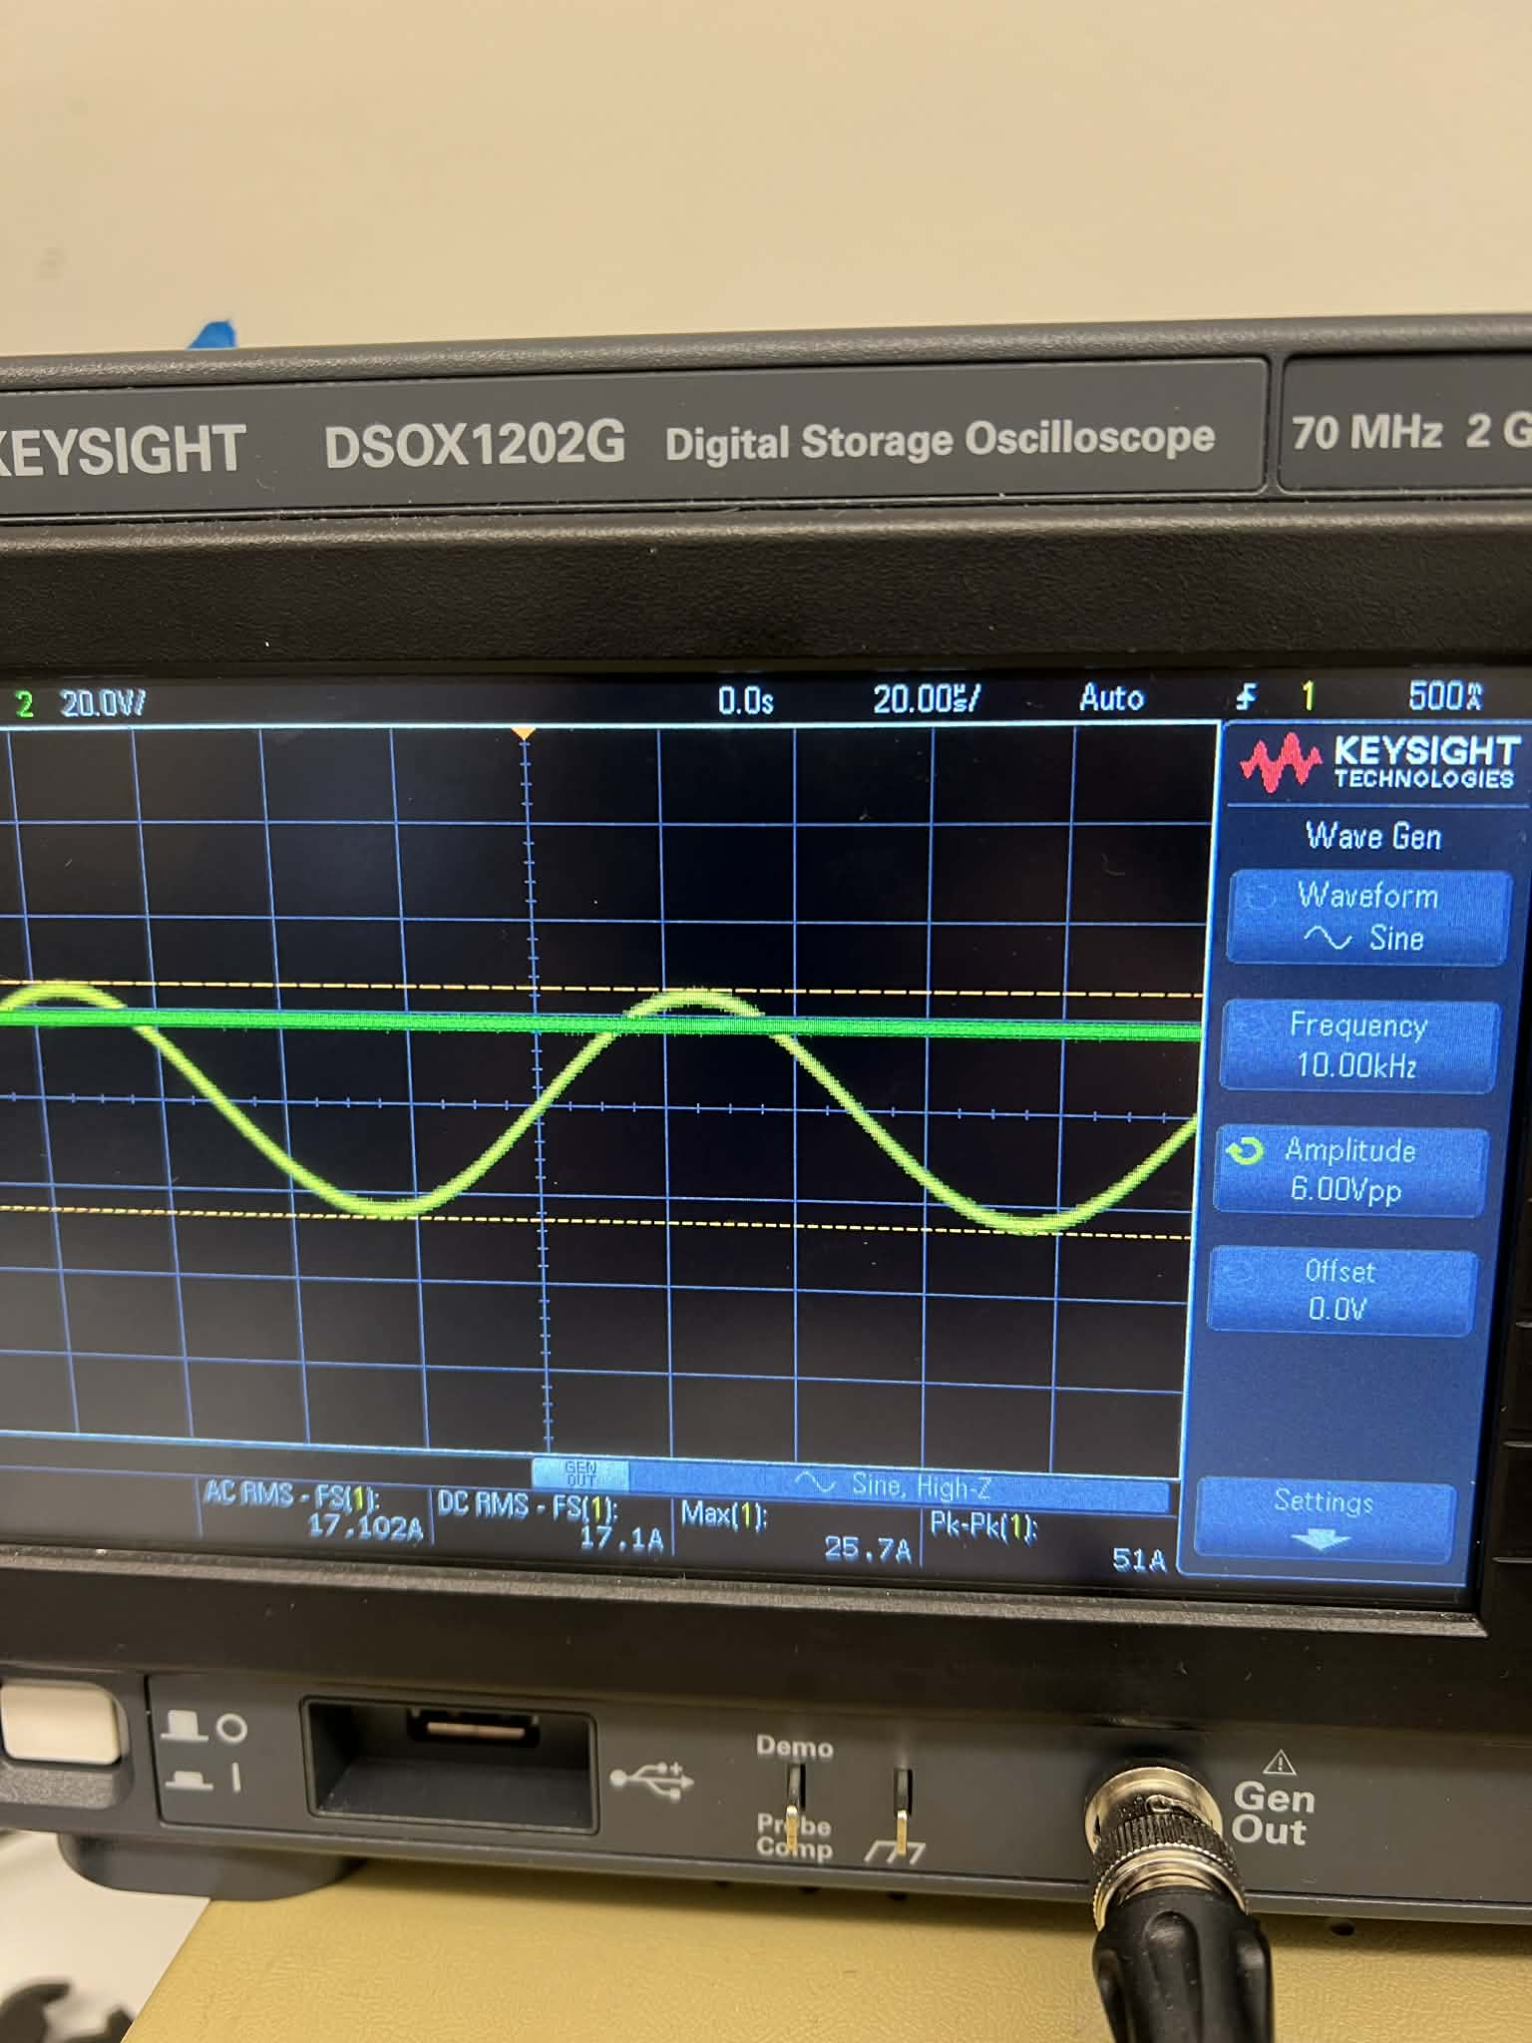
Figure 10kHz with Gen Out input
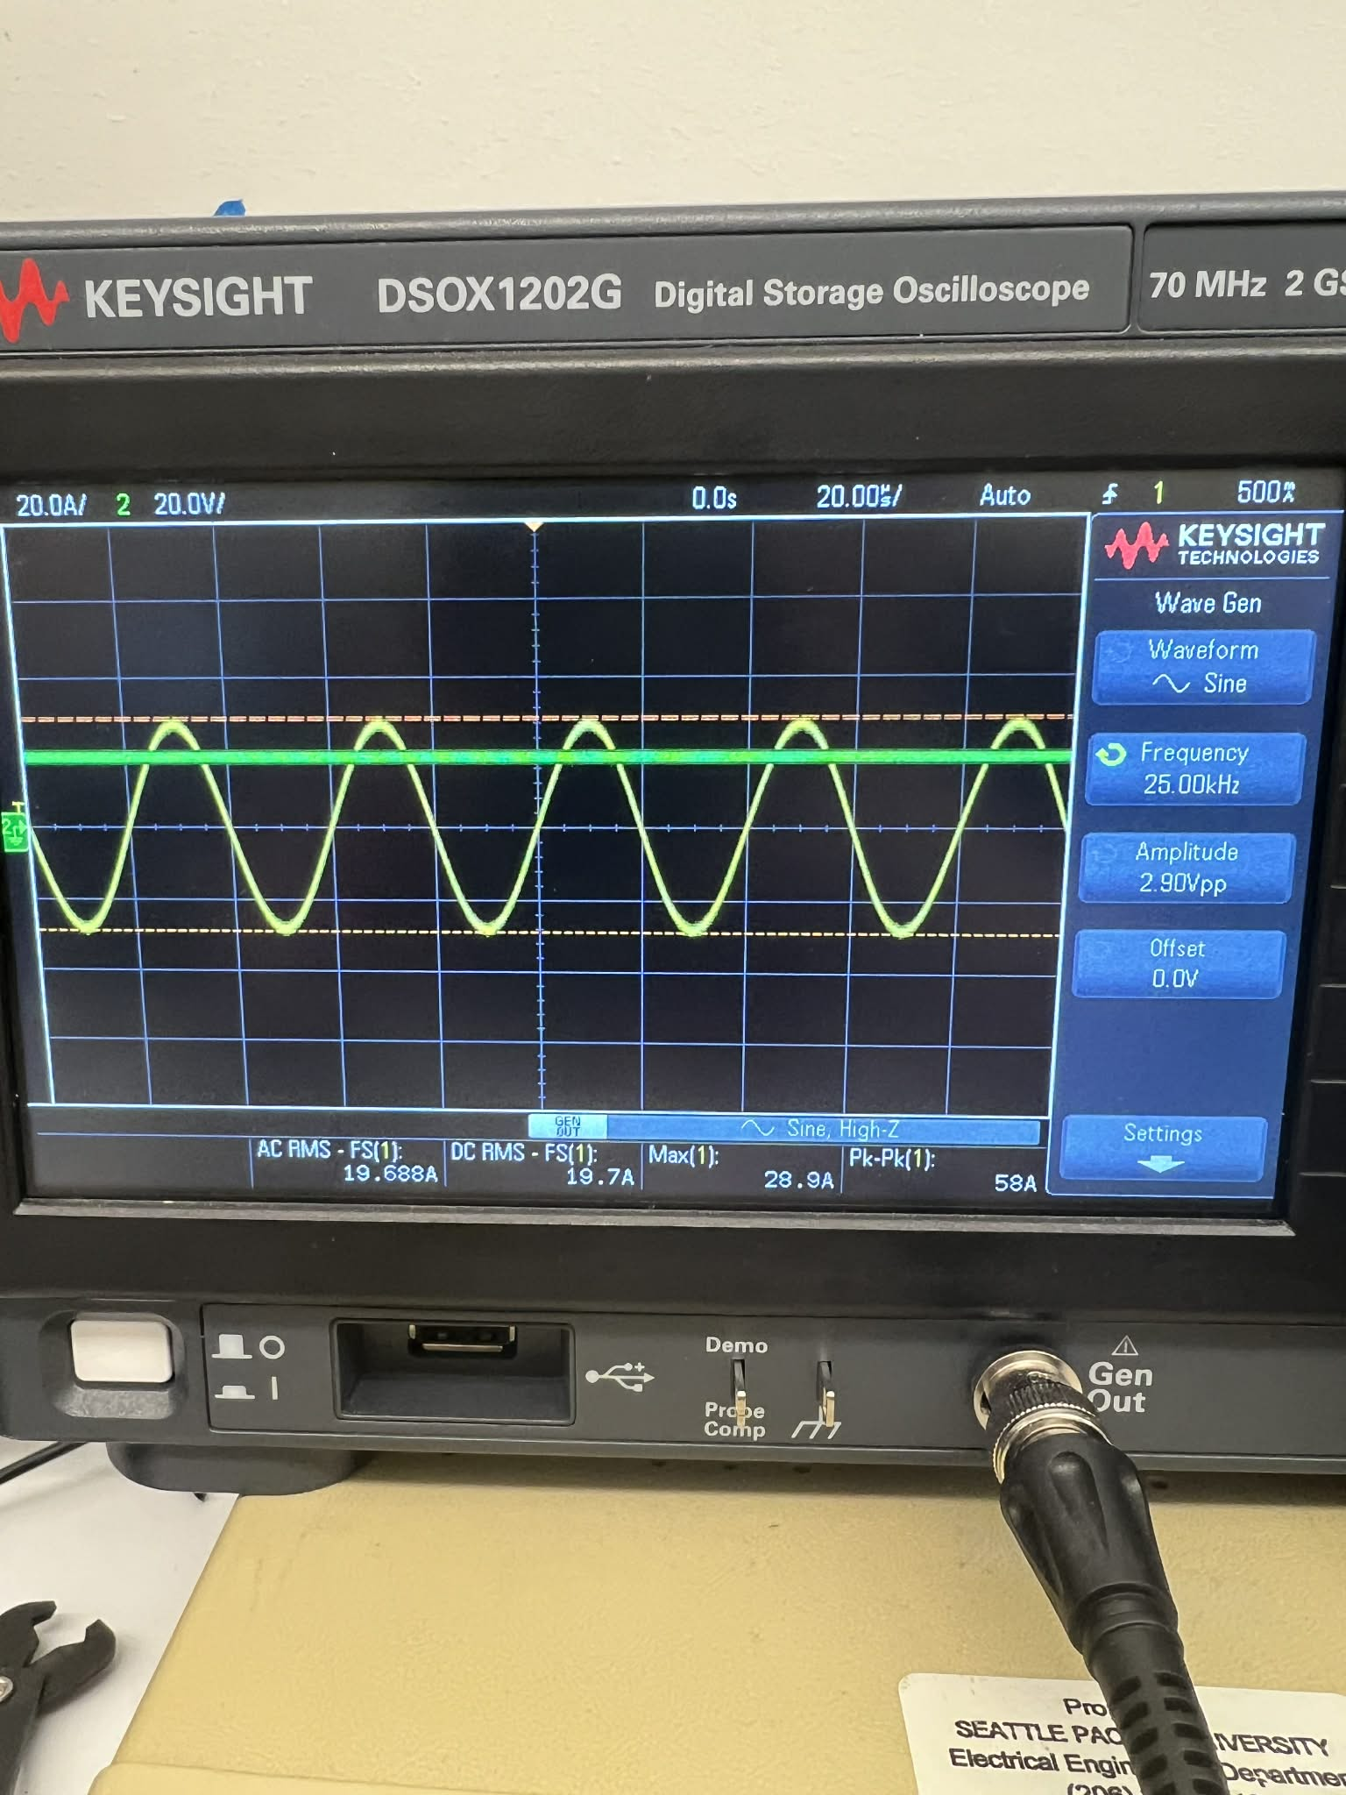
Figure 2 25kHz with Gen Out input
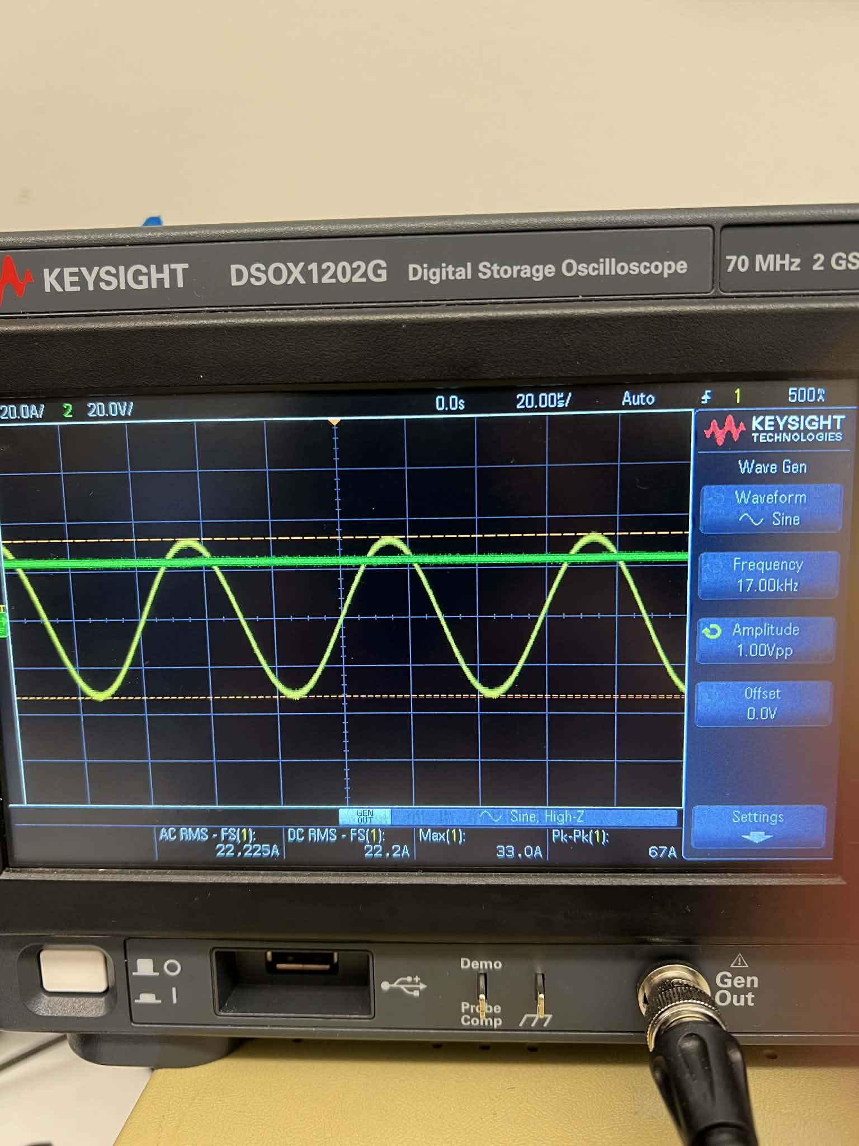
Figure 3 17kHz with Gen Out input
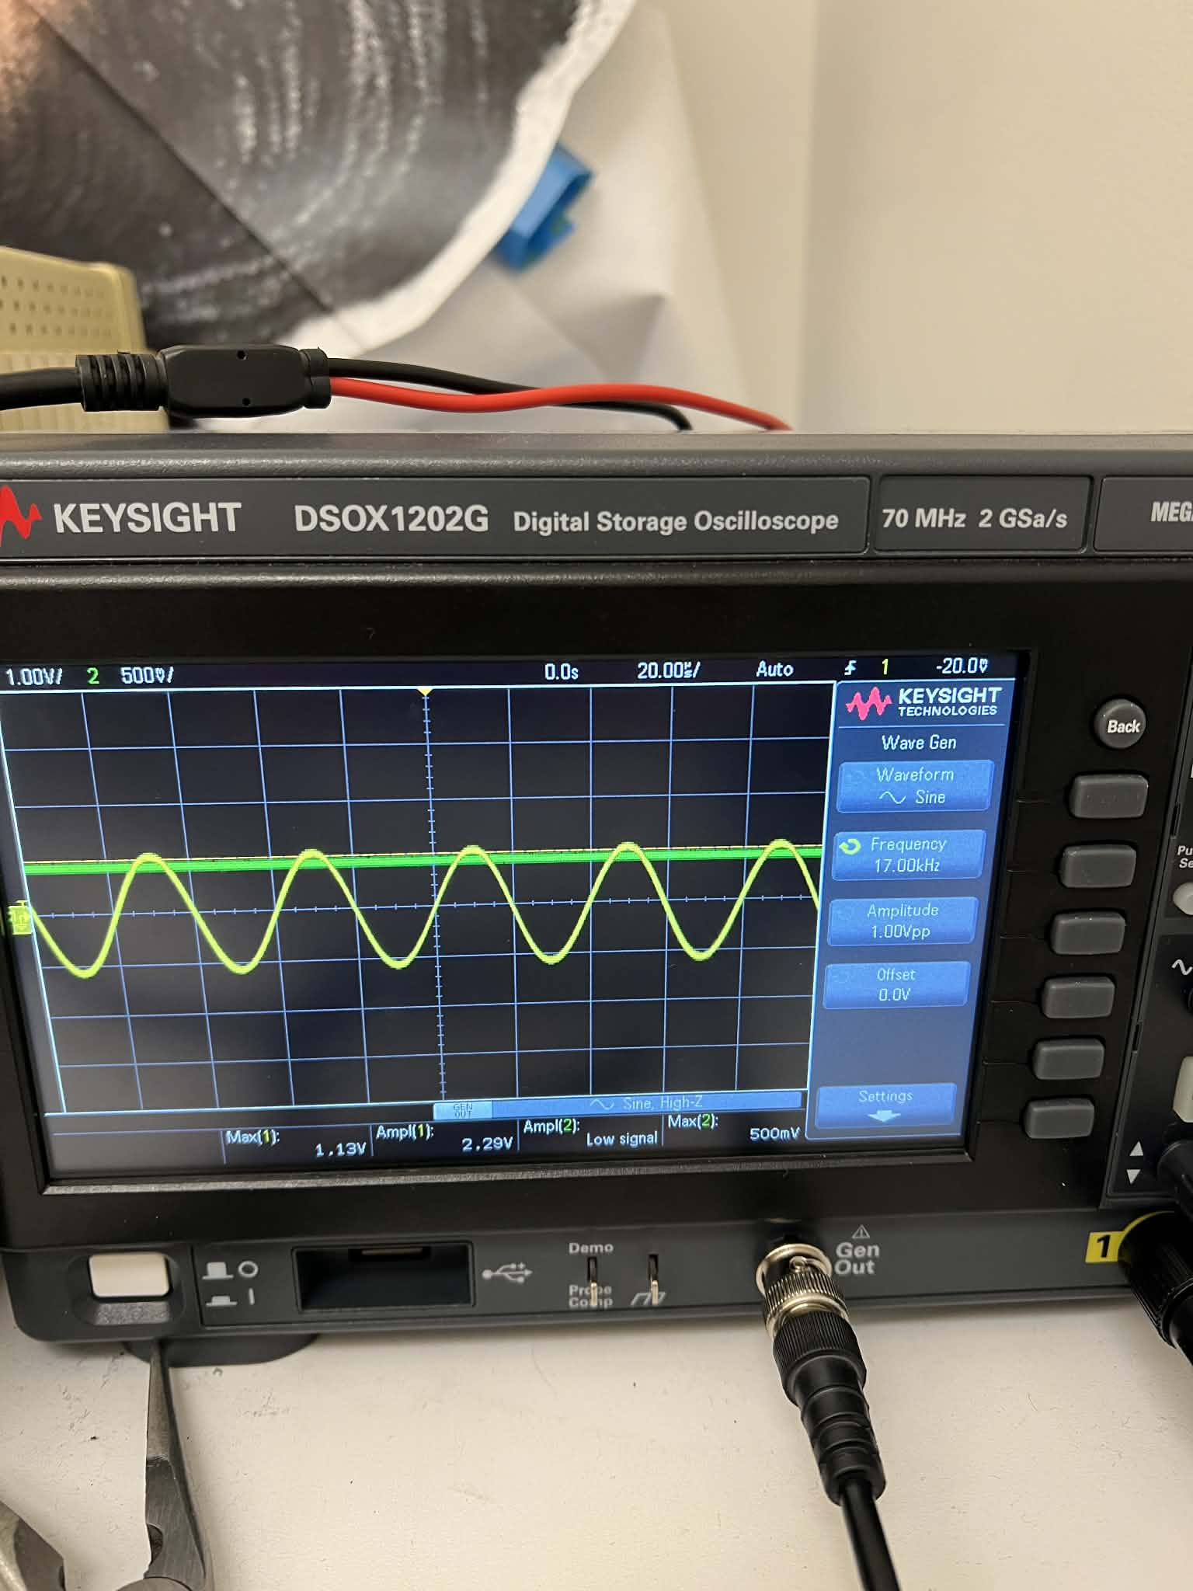
Figure 4 25kHz with IR system input
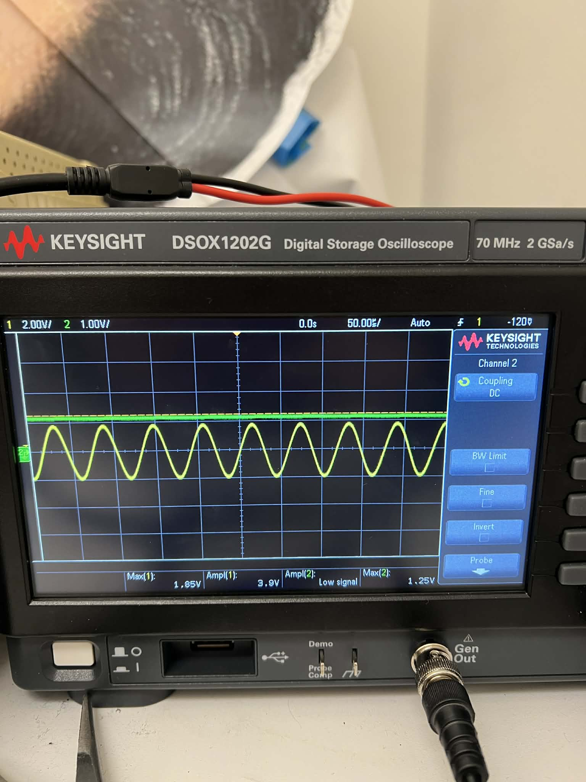

Figure 5 17kHz with IR system input
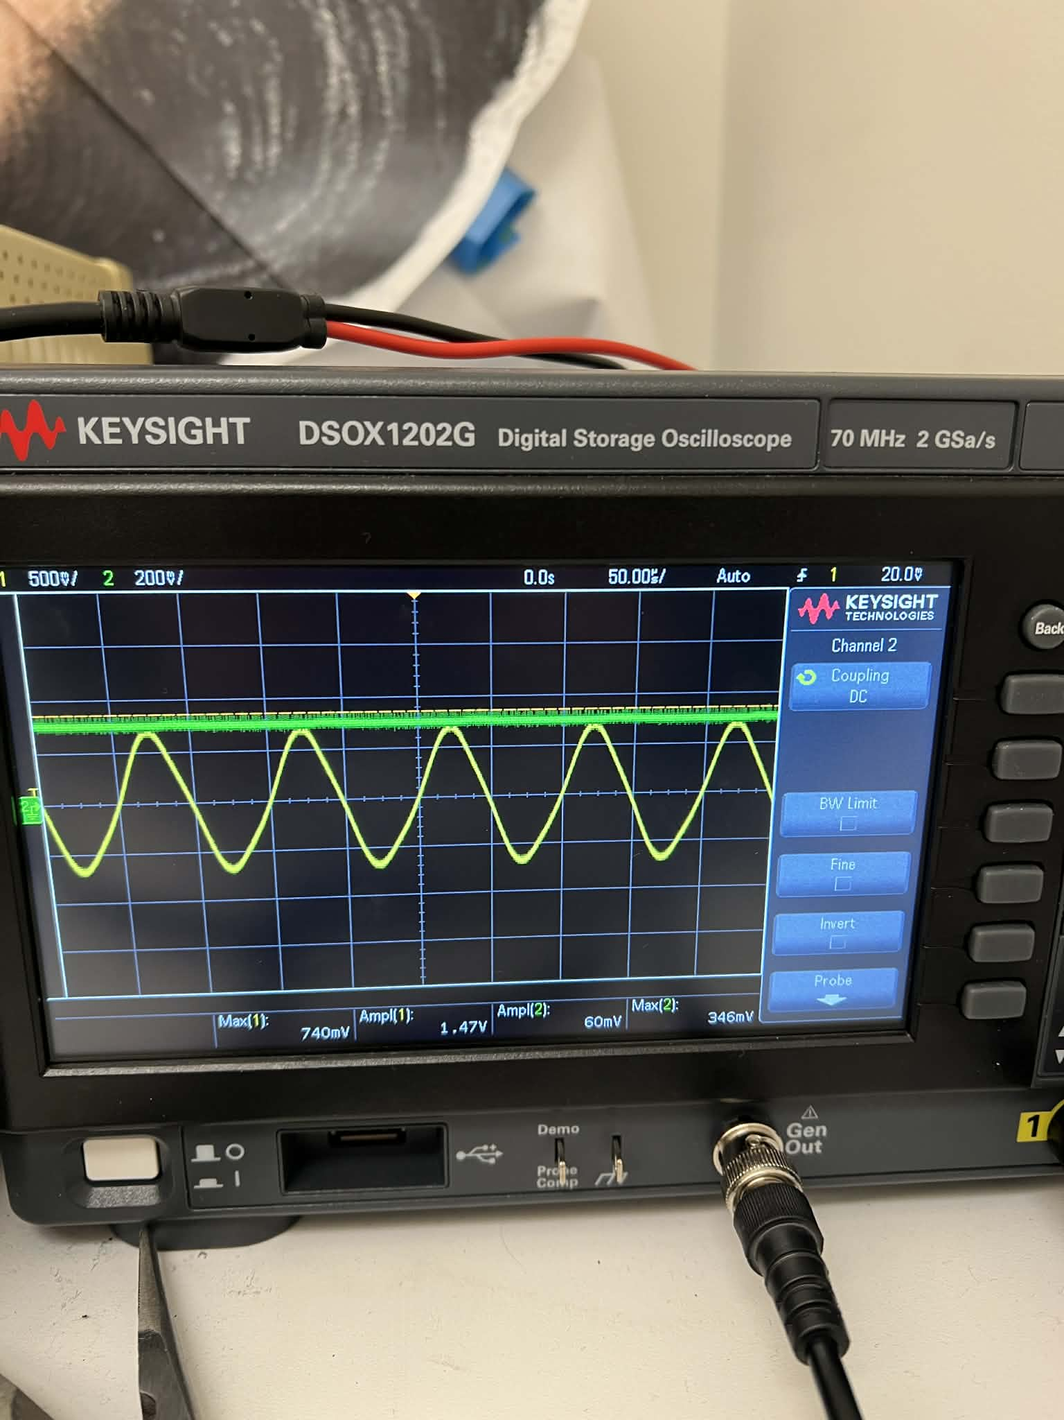
Figure 6 10kHz with IR system input
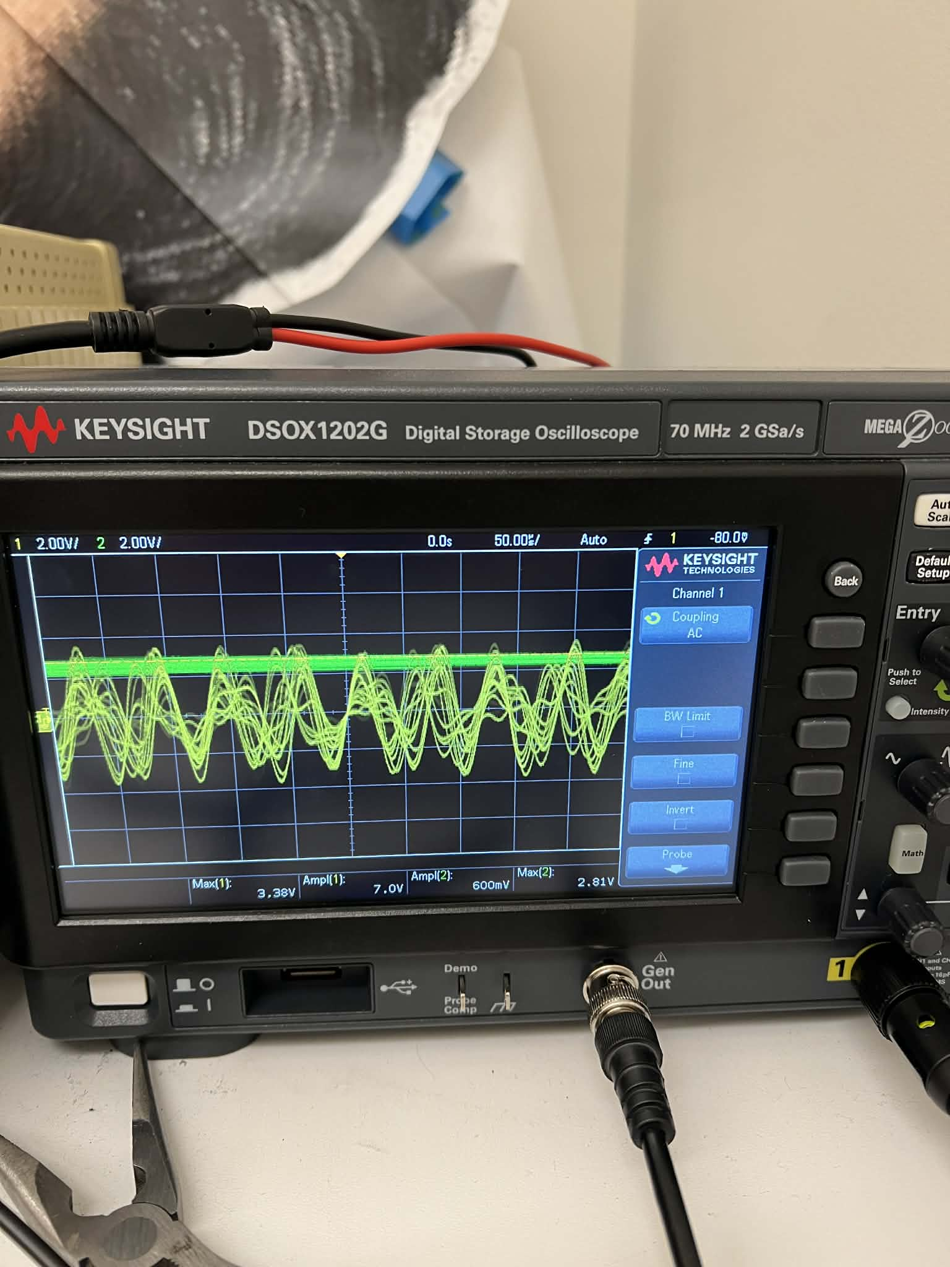
Figure 7 All three frequencies switch turn on
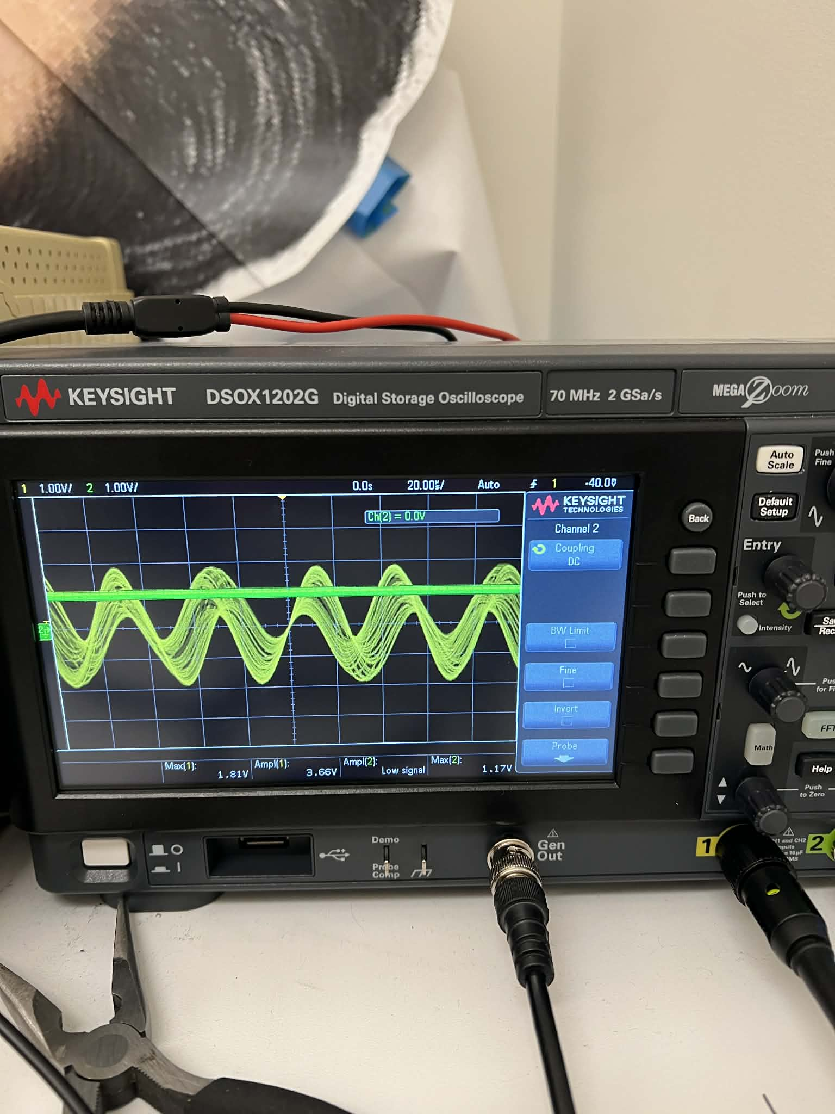
Figure 8 Two Frequencies Neighbor Switch turn on
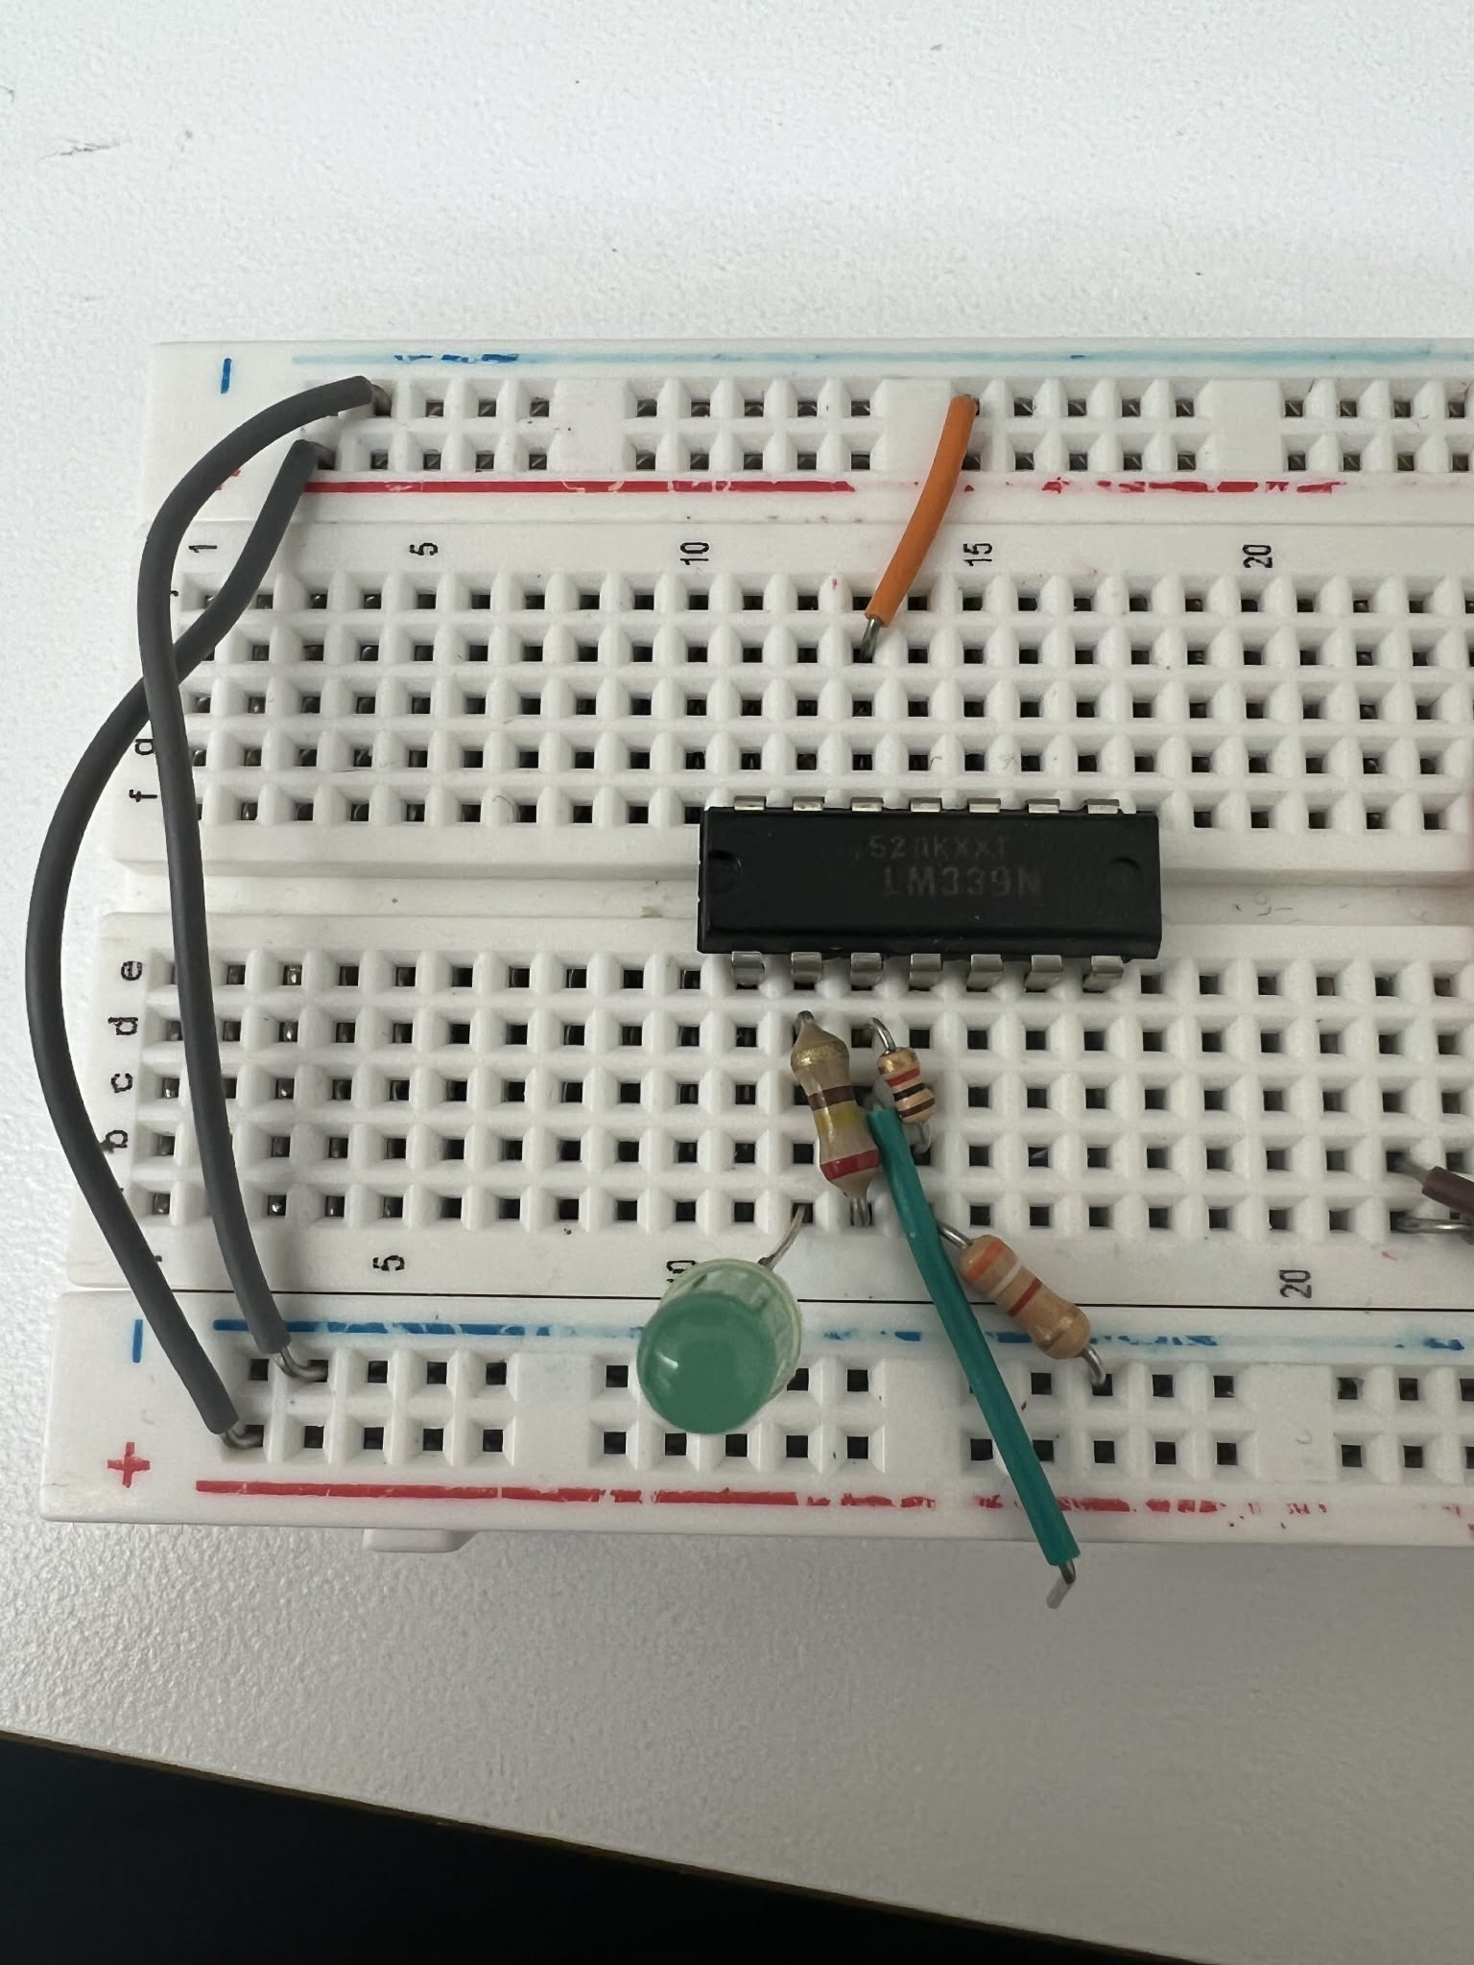
Figure 9 Comparator Build with LED

